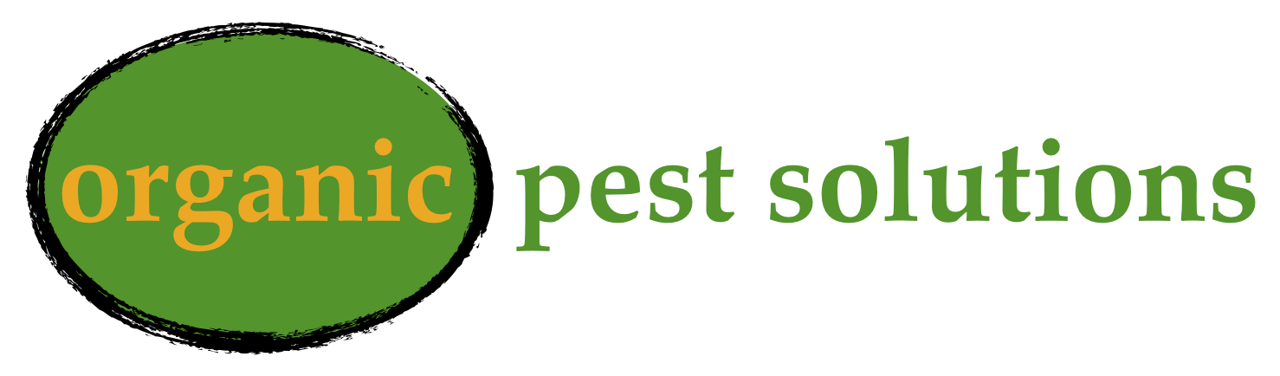
Contract for Annual Pest Control

This contract is entered upon by
Organic Pest Solutions, 9 Shamrock Lane, Greenville, SC 29609 and
Name: _______________________________________________
Address: _____________________________________________
Email: _______________________________________________
from now on known as “the Client”) for quarterly/monthly service, which includes free service calls in between quarterly treatments in the amount of _________per quarter or _____________ in one annual payment.

Service Covered Terms:
- Organic Pest Solutions agrees to service the Client’s main residence (detached buildings are not included in the price) every 3 months with treatment as needed.
- Organic Pest Solutions also agrees to Service Calls between treatments at No Charge if the Service Call is at least 2 weeks from initial treatment or any other Service Call(unless specified by technician) and the client has complied with recommendations for exclusion and or repairs to the structure.
- This contract does not include wood destroying organisms such as, Carpenter Bees, Termites, Carpenter Ants… The list of organisms is not limited to this example list.
- Organic Pest Solutions will treat to 2 feet from the residence as a perimeter treatment, but anything outside of the 2 foot perimeter will be charged as a separate treatment.

Contract Terms:
- Organic Pest Solutions reserves the right to terminate the contract for any reason including but not limited to non-payment, late-payment, non-cooperation with respect to recommendations. If Organic Pest Solutions cancels a standing contract, the client owes no penalty.
- Organic Pest Solutions is entering this contract in Good Faith expecting payment within 7 days of any treatment.
- The Client agrees to make payment on day of service or make arrangements to pay within 7 days of treatment.
- The Client may cancel this contract at any time. The Client agrees to pay 30% of remaining balance of the contract to Organic Pest Solutions within 7 days of contract cancellation.
- This Contract will automatically renew at the 1 year mark and may be cancelled without penalty between the last treatment of the annual agreement and the renewal date.
- Client agrees to pay all fees or legal costs in collecting non-payment from said Client.
- Contract is transferable during a merger, acquisition, name or ownership change with the understanding that the terms of the service agreement and quality will be maintained.

Organic Pest Solutions:__________________________________ Date:___________________

Client:________________________________________________ Date:___________________

